***This document serves as a template sample to demonstrate the structure and content for documenting your results with your own data.***

**Test Evidence**

1. Insert spectator **- Transactions of Interest(A)**

Sql - call insert_spectator(12,'sname12','sname12@mail.com');

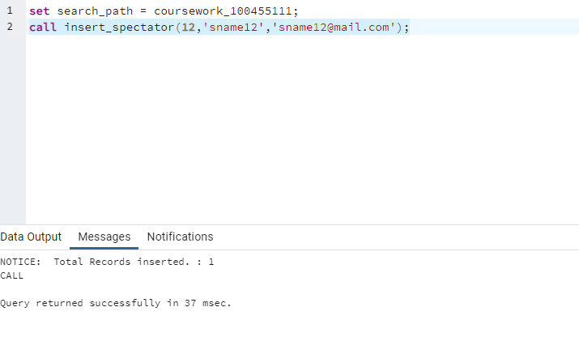

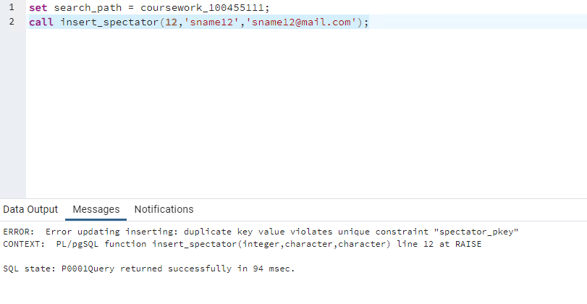

Insert event **- Transactions of Interest(B)**

* **Insert** **event**

Sql - call insert_event('A114','event114','location114','2024-07-01','17:00',10);

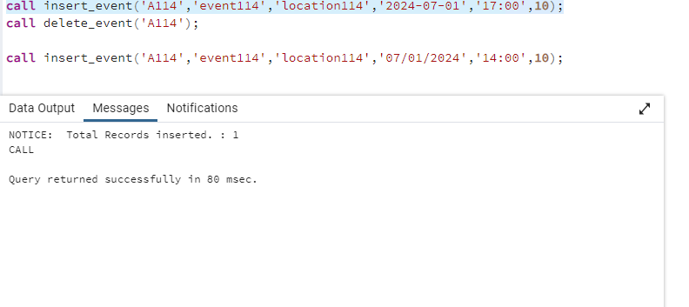

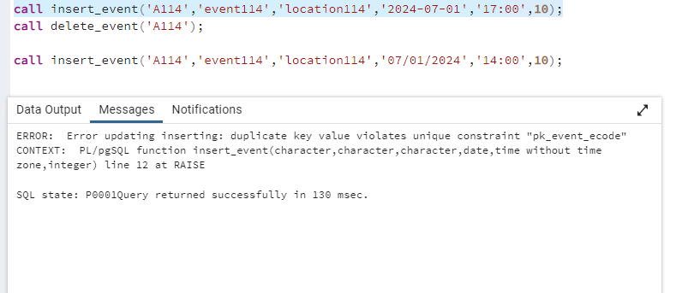

* **Insert into event fails when edate is not July 2024**

Sql - call insert_event('A114','event114','location114','2024-08-01','17:00',10);

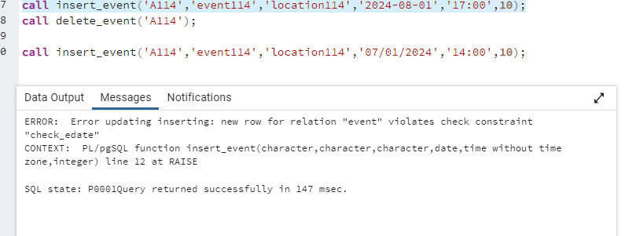

* **Insert into event fails when when etime is before 9:00 hrs**
* **Sql -** call insert_event('A114','event114','location114','2024-07-01','08:00',10);

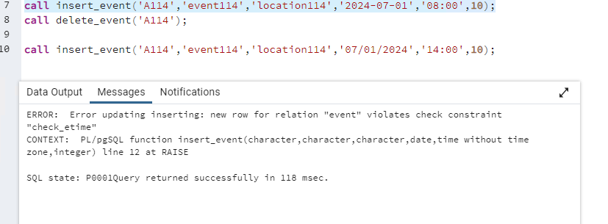

* **Insert into event fails when when emax -0**

sql - call insert_event('A114','event114','location114','2024-07-01','09:00',0);

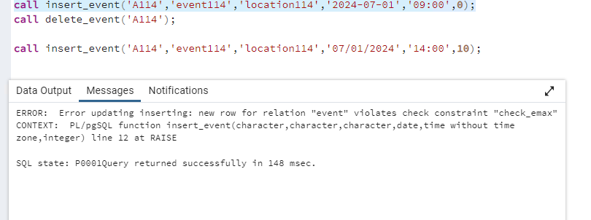

**Transactions of Interest(C)**

* Insert Spectator

Sql - call insert_spectator(13,'sname13','sname13@mail.com');

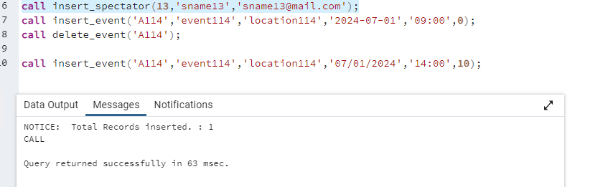

* Delete Spectator when spectator doesn’t have tickets

call delete_spectator(13);

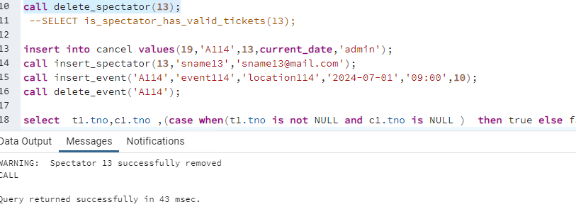

* Delete Spectator when spectator has valid tickets not cancelled

call insert_ticket('A114',13);

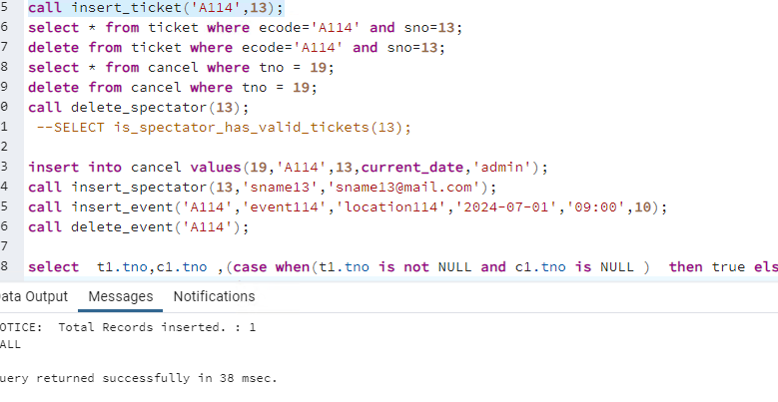

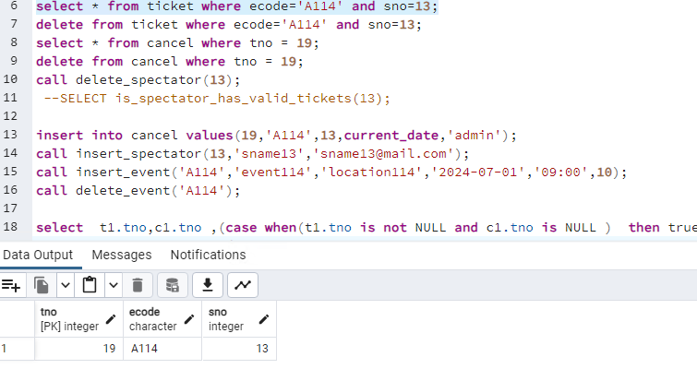

Sql -call delete_spectator(13);

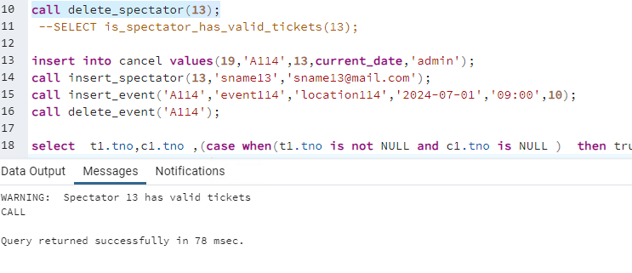

* Delete Spectator when spectator has valid tickets but cancelled

insert into cancel values(19,'A114',13,current_date,'admin');

call delete_spectator(13);

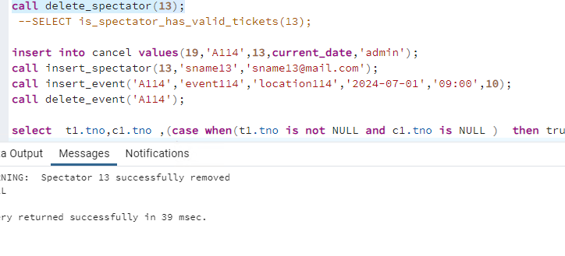

. **Transactions of Interest(D)**

* Delete an event – transaction D

Event record gets deleted for ecode ‘A101’

Ticket record gets deleted for ecode ‘A101’

Cancel has the cancelled record for ‘A101’

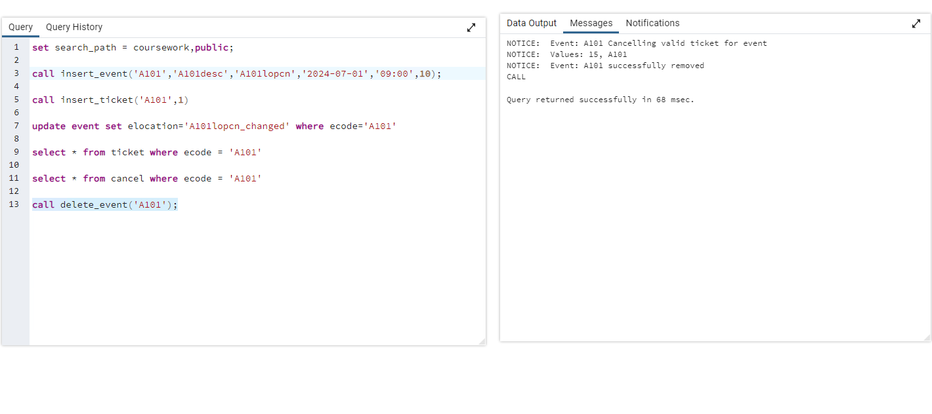

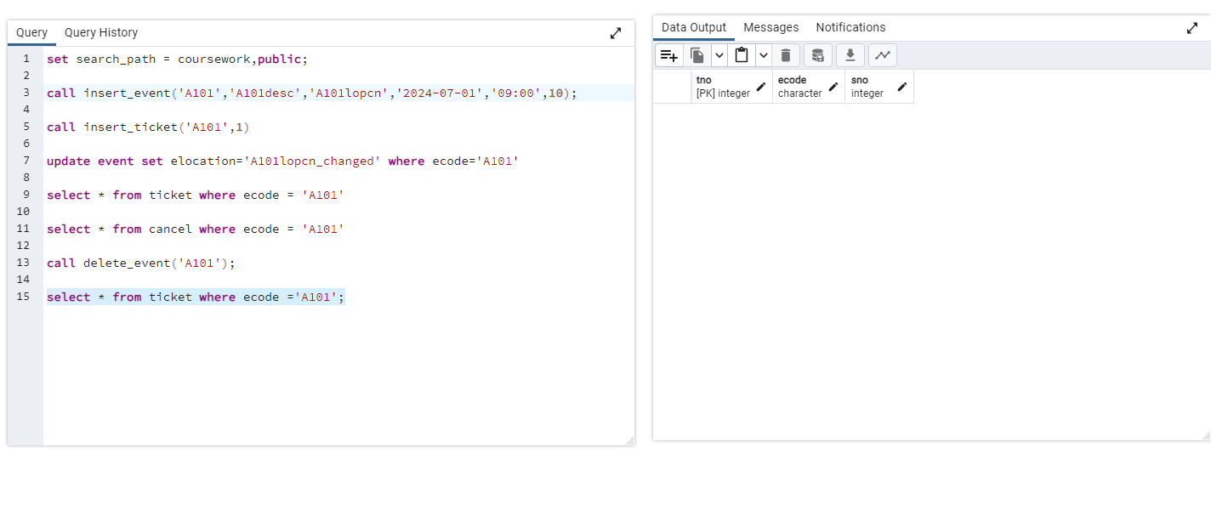

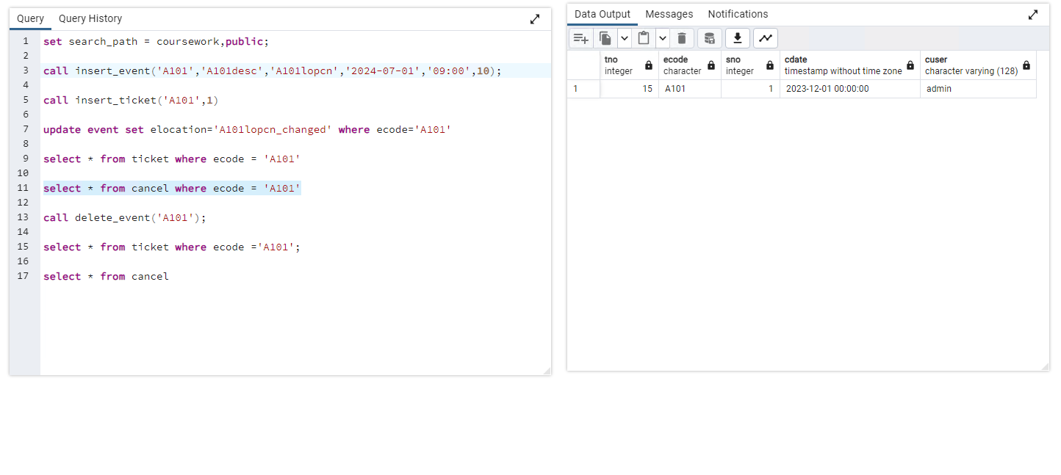

* **Transactions of Interest(E)**

Issue a ticket for an event

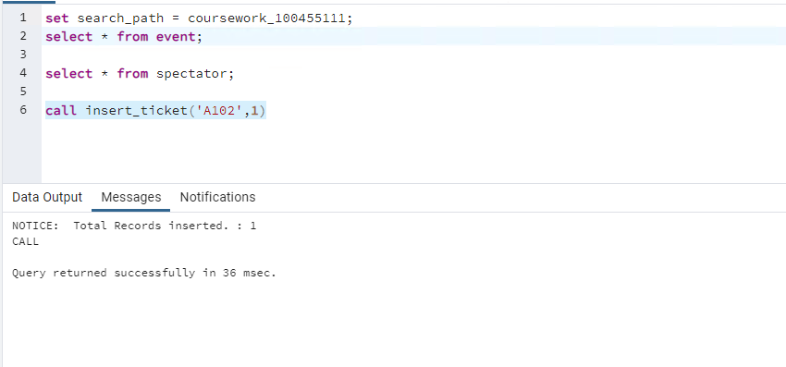

* **Issue ticket for more than 1 ticket for the same event and spectator no**

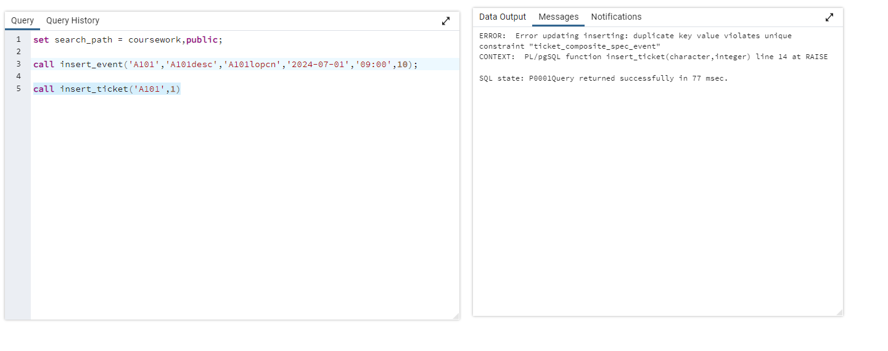

* **Transactions of Interest(F)**

report showing the total number of spectators liable to travel to a location

select * from total_spectator_per_date_per_location;

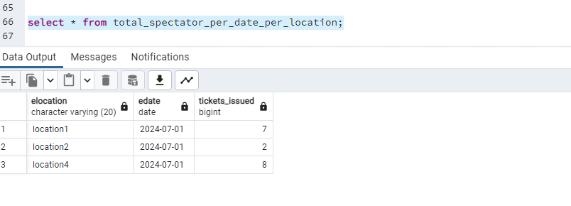

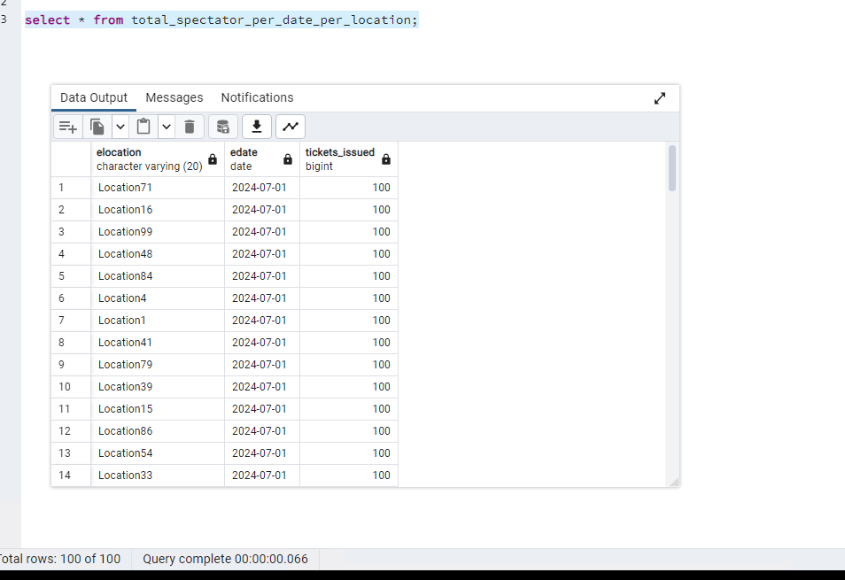

g. Transactions of Interest(G)

report showing the total number of tickets issued for each event.

select * from total_tickets_issued_per_event ;

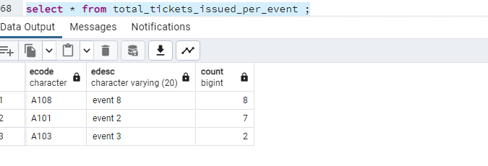

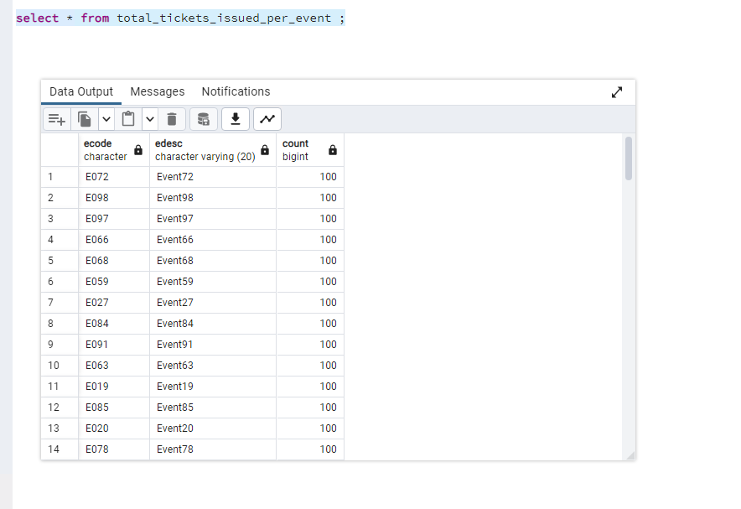

**h.** Transactions of Interest(H)

**report showing the total number of tickets issued for each event by the event code**

select * from total_tickets_issued_per_event where ecode='A101';

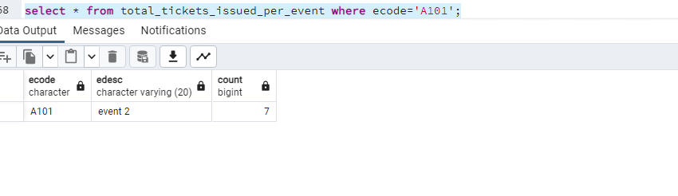

1. Transactions of Interest(I)

**report showing the schedule for a given spectator**

select * from report_spectator_schedule where sno=1;

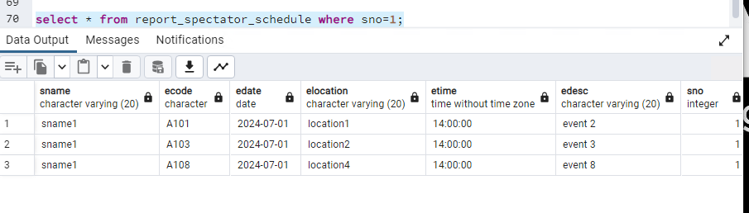

1. **j.** Transactions of Interest(J)

**Given a specific ticket reference number, display the name of the spectator and the event code for the ticket and indicate if the ticket is valid or is cancelled.**

select * from ticket_status_report where tno=9

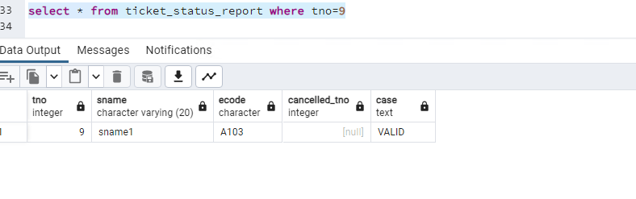

select * from ticket_status_report where tno=12

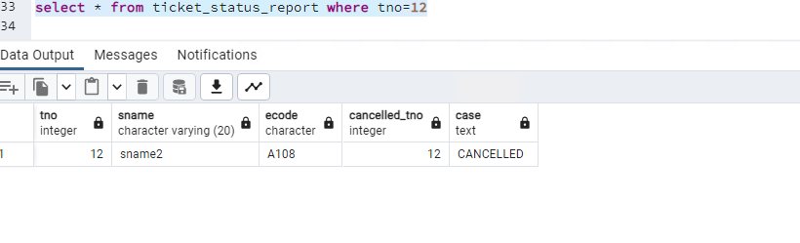

**k.** Transactions of Interest(K)

**View the details of all cancelled tickets for a specific event.**

select * from cancelled_tickets_report where ecode='A108';

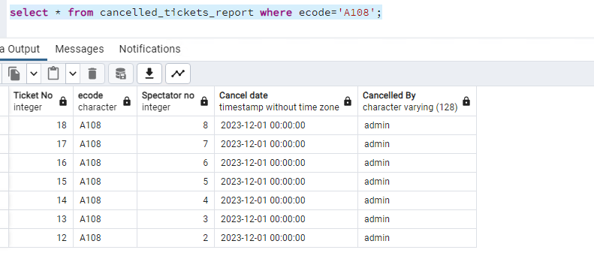

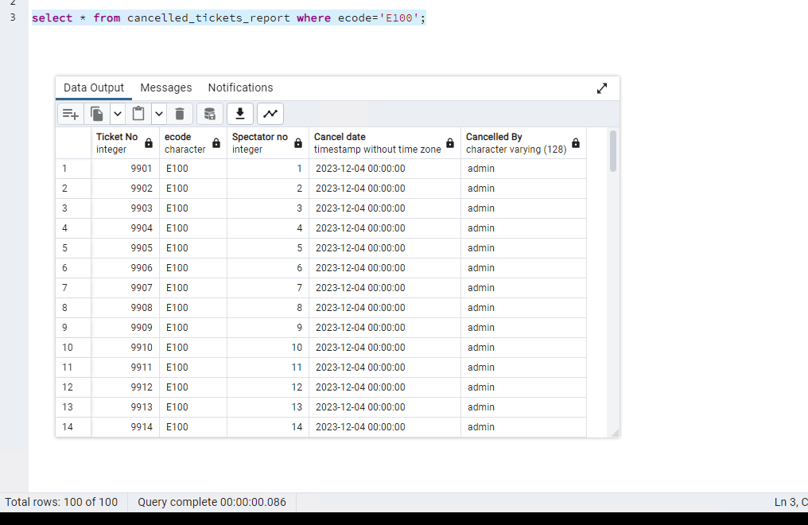

**l.** Transactions of Interest(L)

**Delete the contents of the database tables**

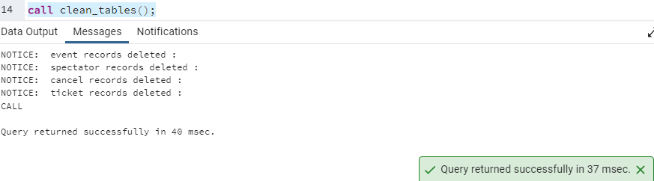

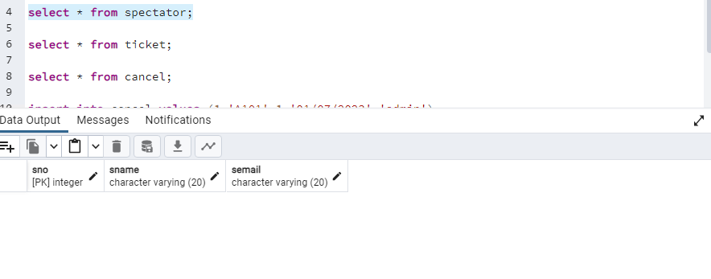

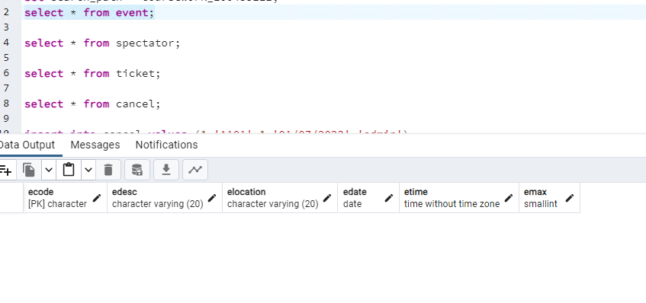

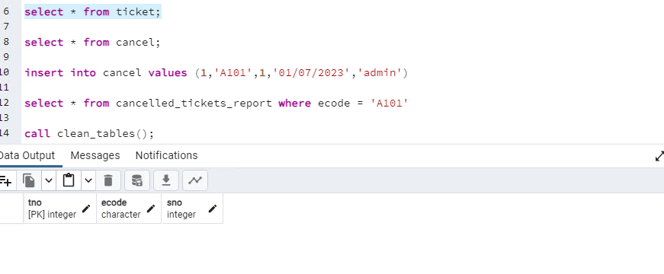

* **When event location changes , ticket gets cancelled**

